UNIVERSITY OF MEDICINE AND PHARMACY “CAROL DAVILA” BUCUREȘTI

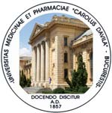

FACULTY OF MEDICINE - DEPARTAMENT 5 CLINIC
INTERNAL MEDICINE AND RHEUMATOLOGY CLINIC
“DR. I. CANTACUZINO” HOSPITAL

HABILITATION THESIS

ABSTRACT
EARLY ARTHRITIS CONCEPT APPLICATIONS IN INFLAMMATORY RHEUMATIC DISEASES

AUTHOR: ASSOCIATE PROFESSOR. DR. MIHAI BOJINCĂ

2019
The habilitation thesis “Early arthritis concept applications in inflammatory rheumatic diseases” is structured in three parts. First part is presenting the medical, academic and scientific development of the author, the second part is presenting applications and possible future development of early arthritis concept in inflammatory rheumatic diseases and the third part is presenting the plans of academic development of the author and concluding remarks.
The medical, academic and scientific development of the author,
Medical training and development
I have graduate the Faculty of General Medicine of IMF “Carol Davila” București in 1990. In 1991, after the participation to the national competition for medical and surgical specialties, I was admitted as trainee in Internal Medicine and I have worked in the Internal Medicine and Rheumatology Clinic of the “Grivita” Hospital (current “Sf. Maria” Hospital) between 1992 - 1994. In 1994 I was confirmed as Internal Medicine specialist (ordin MS nr. 2214 / 1994) and in 1995 I became assistant professor in Internal Medicine and Rheumatology Clinic of “Dr. I. Cantacuzino” Hospital, București, where I am still working present days. After that I have continued my training in Internal Medicine but also in Rheumatology and I became Rheumatology specialist in 1998 (ordin MS 1011/1998). Later I became consultant in Internal Medicine in 1999 (ordin MS 637 / 1999) and Rheumatology in 2003 (ordin MS 846 / 2003). In 2000 I have applied for the position of head of section Internal Medicine 1 in the Internal Medicine and Rheumatology Clinic of “Dr. I. Cantacuzino” Hospital (ordin MS 478 / 2000), position held till present days. Between 2009 - 2011 I was an ad interim medical director of “Dr. I. Cantacuzino” Hospital. I was secretary of Rheumatology Comitee of Health Ministry between 2004 - 2006 and member of this committee between 2013 - 2014. As a part of my training I have participated in more than 100 courses, conferences and congresses and I quote the Romanian Internal Medicine and Rheumatology Congresses and the EULAR Congresses and the ACR Meetings. I am a certified ultrasonographer (general ultrasonography) (certificat seria A nr. 005713, 7629 / 29.05.2002) and in 2015, after the participation in several EULAR courses in Musculoskeletal Ultrasonography, I was confirmed as EULAR trainer in Musculoskeletal Ultrasonography (Level 2 of the EULAR Competency Assessment in MSUS. After the participation to ISCD (International Society of Clinical Densitometry) courses and exams I became CCD (Clinical Certified Densitometrist). Working with colleagues of the clinic, we have participate to the introduction in clinical practice of modern treatments in Rheumatology, as biologic therapies, targeted synthetic therapies, hyaluronic acid, platelets rich plasma (PRP), extracorporeal shockwave therapy (ESWT) and the others. Our clinic is a training center for Internal Medicine, Rheumatology and Musculoskeletal Ultrasonography.
Academic development
In 1995 I became an assistant professor in the Internal Medicine and Rheumatology Clinic of “Dr. I. Cantacuzino” Hospital under the supervison of prof. dr. Ștefan Șuțeanu. In 1996 I have started to prepare my PhD thesis also under the supervision of prof. dr. Ștefan Șuțeanu. In 1998 I have participated to the medical teachers training “Teaching the teachers” organized by the University of Bristol and UMF Carol Davila at Bristol Royal Infirmary, Bristol, UK (coordinator Mark Brennan). After that I was a member of the team who organized the same type of course for our colleagues from UMF Carol Davila in 1999 and 2000. I have finished and defended my PhD thesis in 2004. The title of my thesis was “Pathogenical, immunological, clinical and therapeutical aspects in severe forms of rheumatoid arthritis”, under the supervision of Prof. Dr. Şt. Şuţeanu (ordin MEC 5237 / 2004). In 2004 I became a lecturer and in 2007 I became associate professor in the Internal Medicine and Rheumatology Clinic of “Dr. I. Cantacuzino” Hospital, UMF Carol Davila București. I am a member of the Romanian Society of Internal Medicine and a member of the Romanian Society of Rheumatology. I was a member of the Romanian Society of Rheumatology Committee between 1999 and 2011 and a vice-president of the society between 2011 and 2015. Currently, I am a member of the specialty committee of the society. I have participated to the organization of national and international scientific events, including national congresses of Rheumatology and Ultrasonography courses. In our clinic, I am coordinating the Rheumatology and Musculoskeletal training of medical residents. I have participate (with colleagues of the clinic) to the elaboration of many chapters of the Rheumatology course of UMF “Carol Davila” and of the book “Esentialul in Reumatologie” coordinating author - prof. dr. R. Ionescu. My teaching activity is completed with Rheumatology lectures and participations to exams. Scientific development
I am a member of the editorial board of Romanian Journal of Rheumatology and I was a secretary of the board between 2000 and 2004. I have participated to the development of two research centers in our clinic: the Early Arthritis Research Center (certified in 2005) and the Research Center in Rheumatology for medical students. I have coordinated graduate papers for medical students and I was a PhD reviewer for 30 PhD thesis from our university but also from other medical universities as Craiova, Constanţa and Târgu Mureş. I have participated to many research projects financed by CNCSIS (as a team member, partner coordinator or head of the project), research projects without financing or financed by sponsors and also to national and international clinical studies. My PhD thesis was focused on rheumatoid arthritis and as a part of the work I have worked together with a group of researchers in Molecular Biology and Genetics. This cooperation has offered us very interesting data about the presence and the role of the “shared epitope” (rheumatoid epitope) in Romanian patients with rheumatoid arthritis. As a result, I have participate (with colleagues of the clinic) in many research projects about genetic aspects of the inflammatory rheumatic diseases” Molecular diagnostic and prognostic aspects in rheumatoid arthritis – 2002; Study of the genetic and immunological components in Romanian patients with rheumatoid arthritis 2005 – 2006; Secondary genetic associations in seronegative spondyloarthritis 2007 – 2009. I have also participate to other research projects as ARMS, DEMETRA, OMERACT – EULAR project regarding the productivity loss in patients with inflammatory arthritis or osteoarthritis, PROMPT, LUMINA, ULLYSES and others. As an invited expert, I have participated in POSDRU projects - PERFORMED and others.
I have contributed to the elaboration of many scientific works presented in national and international congresses – more 150 posters and oral presentations at national Rheumatology and Internal Medicine congresses, 75 posters at EULAR congresses and 18 posters and oral presentations at ACR Meetings. I am the author or co-author of more than 50 published papers in national journals, 39 Pubmed indexed papers and 27 ISI Thompson – Web of Science indexed papers, with Hirsch index of 7. I have participated as author, co-author or coordinating author to many books and chapters as follows:
- M. Bojincă – „Immunogenetic implications in the evolution of rheumatoid arthrtis”, Editura Tehnoplast, 2006, Bucureşti, ISBN 973-8932-06-8.
- V. Bojincă, M. Milicescu, M. Bojincă – „Updates in diagnosis and treatment of osteoporosis” – Editura Tehnoplast, 2006 Bucureşti, ISBN 973-8932-01-7.
- O.M. Popa, M. Bojinca – Psoriatic arthritis. Editura Etna 2016, ISBN 978-973-1985-10-7.
- M. Bojincă, Violeta Bojincă - “Laboratory work-up in connective tissue diseases ” în vol. “Explorări funcţionale”, pp. 241-255, Editura Cerma, 2000 Bucureşti, ISBN 973–9266–39-8.
- Şt. Şuţeanu, P. Ignat, M. Bojincă, Mariana Sasu – „Mixed connective tissue disease” Medicina Intern, sub red. L. Gherasim, vol. I, ed. II, Editura Medicală, Bucureşti 2000, pag. 729-736, ISBN 973–39–0254-3.
- M. Bojincă – „Genetic aspects in rheumatic diseases”, „Esenţialul în Reumatologie” sub red. R. Ionescu, Editura Medicală Amaltea, 2006 Bucureşti, ISBN 973-7780-46-9.
- M. Bojinca – „Early arthritis, which way?” – „Artrita precoce” sub red. C. Codreanu, Editura Universitara Carol Davila 2016, ISBN 978-973-708-925-0.
- M. Bojinca – „Osteoporosis in hematologic diseases” – „Osteoporoza din perspectiva multidisciplinara” sub red. V. Bojinca, Editura Etna 2017, ISBN 978-973-1985-21-3
Part II - Applications and possible future development of early arthritis concept in inflammatory rheumatic diseases
Early arthritis concept was elaborated and studied after 1990 in some Rheumatology departments from Netherlands, UK and Austria. They tried to find solutions to decrease the delay in the diagnosis of rheumatoid arthritis and to increase treatment effectiveness. The success of this approach has lead to a general use in Rheumatology clinical practice. This success was helped also by the development of new and more effective methods of diagnostic and treatment (especially biologic therapies). From the early arthritis concept, the next step was the implementation of treat to target strategy (T2T), strategy that was able to produce spectacular results in a disease considered for centuries, incurable. Nowadays early arthritis concept and T2T strategy are extended to other inflammatory rheumatic diseases as spondyloarthritis, psoriatic arthritis, systemic lupus erythematosus, vasculitis and other. New classification criteria and guidelines have been also implemented in the last years, and early diagnosis and treatment and the application of T2T strategy are now the cornerstone of the inflammatory rheumatic diseases management. The extraordinary progress in the diagnostic and treatment of the inflammatory rheumatic disease was a direct consequence of the advances in the research of genetic, immunologic and pathogenic aspects of these diseases. As a part of my scientific activity I have studied the role of “shared epitope” (QKRAA – position 70 – 74 of the beta chain of HLA-DR4) in the development and evolution of rheumatoid arthritis, the role of matrix metalloproteinases (MMP) in rheumatoid arthritis, genetic aspects in spondyloarthritis and other. As a part of the study about shared epitope, our team has obtained very interesting results concerning the relation between the shared epitope and the activity and the severity of rheumatoid arthritis in Romanian patients:
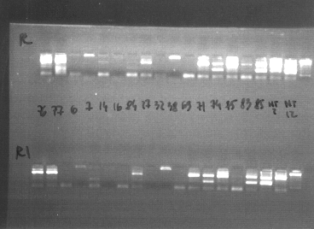
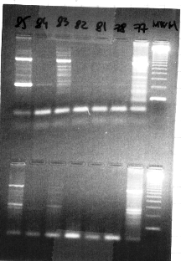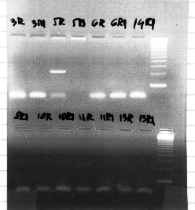
Some of the results of our study shows that:
- Rheumatoid arthritis patients have more frequent HLA-DRB1 allelles (with shared epitope) in comparison with general population.
- The most frequent identified types of epitopes are QKRAA, QRRAA, QKRRA.

- The patients with risk alleles (QKRAA/QKRRA) have more frequently pozitivity for rheumatoid factor.
- The patients with risk allelles (QKRAA şi QKRAA/QKRRA) have more severe and more active forms of rheumatoid arthritis (elevated DAS28.
- The patients with risk allelles are using for larger doses of DMARDs and glucocorticoids and are using more frequent biologic terapies for the control of the disease.

We have studied also the role of MMP in rheumatoid arthritis in comparison with osteoarthritis. The study objectives were:
- The evaluation of the main MMP in the synovial fluid and sera of rheumatoid arthritis patients.
- Comparison of types and levels of MMP from the synovial fluid and sera of patients with rheumatoid arthritis and osteoarthritis.
- Correlations between types and levels of MMP and activity and severity of rheumatoid arthritis

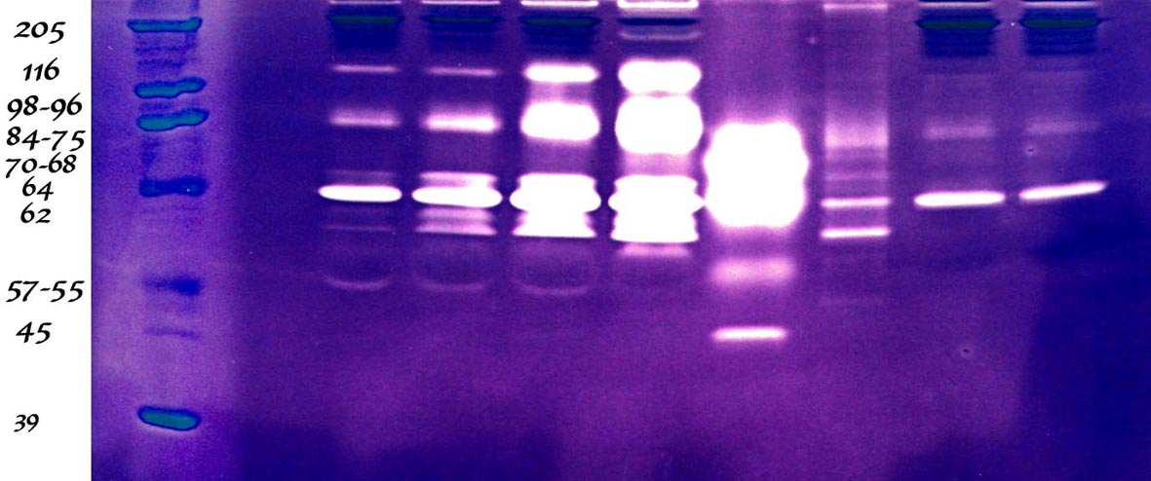

Conclusions of the study
- The gelatinases (MMP2, 9) are the best evaluated by the method used
- The prezence of MMP 2 and 9 and proMMP 1 and 3 in the synovial fluid is clearly differentiating rheumatoid arthritis patients from osteoarthritis patients
- The MMP production is higher in stages II and III of rheumatoid arthritis in comparison with stages I and IV
- Untrated rheumatoid artritis is associated with higher levels of MMP and further structural damage.
- The presence of MMP 9 and proMMP 1 and 3 in the synovial fluid is associated with active, seropositive forms of rheumatoid arthritis and is correlated with ESR and CRP

Genetic aspects in spondyloarthritis

The importance of HLA-B27 in spondyloarthritis and mainly in ankylosing spondylitis is well known. The published data showed the presence of HLA – B27 in 70 – 90% of patient with ankylosing spondylitis and an important presence in patient with other spondyloarthritis like psoriatic arthritis, reactive arthritis. In our research project „ Secondary genetic associations in seronegative spondyloarthritis”, Proiect IDEI ID_695 Nr. 311/2007, during 2007 – 2009 and extended in 2010, we have evaluated the presence of HLA-B27 in a group of Romanian patients with spondyloarthritis in comparison with general population and also the association between secondary genetic characteristics, HLA-B27 and clinical and therapeutical aspects and we have presented and published several papers:
“Introduction to SNP genotyping by Real-Time PCR” – O.M. Popa, M. Bojinca, V. Bojinca, C. Ciofu, C. Bara, L.O. Popa, Travaux du museum National d’Histoire Naturelle “Grigore Antipa”, Vol. 52, p. 515-522, 2009 (categoria B+ CNCSIS).
“Tumor necrosis factor alpha promoter polymorphisms in Ankylosing Spondylitis patients in Romania”, O. M. Popa, M. Bojinca, V. Bojinca, C. Ciofu, R. Sfrent-Cornateanu C. Bara, M. Dutescu, C. Mihai, M. Milicescu, L. Popa EMBO Meeting 2009, August 29-September 1, Amsterdam, The Netherlands
“TNFα promoter polymorphisms in psoriatic arthritis patients in Romania”, O.M. Popa, C. Ciofu, M. Dutescu, M. Bojinca, R. Sfrent-Cornateanu, V. Bojinca, M. Milicescu, C. Bara, L. Popa, European Journal of Human Genetics 17, Supplement 2:255, European Conference of Human Genetics 2009, May 23 – 26, Vienna, Austria.
“Association of HLA-CW*06 with susceptibility to Psoriatic Arthritis and its clinical phenotype in Romania” O. M. Popa, L. Popa, M. I. Dutescu, M. Bojinca, V. Bojinca, C. Ciofu, C. Bara, F. Mrazek, M. Petrek, Tissue Antigens 75, no. 5, p. 627-8, 24th European Immunogenetics and Histocompatibility Conference, May, Florence, Italy 2010
Hsp70 genes polymorphisms: lack of association with Undifferentiated Spondyloarthritis in Romania”, O. Popa, M. Dutescu, M. Bojinca, V. Bojinca, R. Sfrent-Cornateanu, F. Raicu, C. Bara, L. Popa, European Journal of Human Genetics 18, Supplement 1, European Conference of Human Genetics June 2010, Gothenburg, Sweden
TUMOR NECROSIS FACTOR ALPHA PROMOTER POLYMORPHISMS IN UNDIFFERENTIATED SPONDYLOARTHRITIS PATIENTS IN ROMANIA O. M. Popa, M. Bojinca, M. I. Dutescu, V. Bojinca, R. Sfrent-Cornateanu, M. Milicescu, C. Bara, L. O. Popa, Ann Rheum Dis 2010;69(Suppl3):664
The influence of TNF-alpha polymorphisms on the susceptibility and severity of Ankylosing Spondylitis in Romanian patients, Popa O.M., M.I. Dutescu, M. Bojinca, V. Bojinca, C. Bara, M. Meirosu, M. Milicescu, L. Popa, 25th European Immunogenetics and Histocompatibility Conference, Prague, Czech Republic, 4-7 May, 2011
“Distribution of HLA-B27 in Romanian spondyloarthritides patients” - O. M. Popa, M. Bojinca, V. Bojinca, C. Ciofu, M. I. Dutescu, A. Bardan, R. Sfrent-Cornateanu, M. Petrek, C. Bara, L. Popa, International Journal of Immunogenetics, DOI: 10.1111/j.1744-313X.2010.00945.x, impact factor 1.522
HLA-C locus and genetic susceptibility to psoriatic arthritis in Romanian population. Psoriatic arthritis and HLA-C allelic groups in Romania. O. M. Popa¹, L. Popa², M. I. Dutescu³, M. Bojinca⁴, V. Bojinca⁵, C. Ciofu⁴, C. Bara¹, F. Mrazek⁶, M. Petrek^{6,7} . Tissue Antigens 2011, 77, 325–328
A Pilot Study of the Association of Tumor Necrosis Factor alpha polymorphisms with Psoriatic Arthritis in Romanian population. Olivia M. Popa^{1*}, Mihai Bojinca^{2*}, Violeta Bojinca³, Monica I. Dutescu⁴, Mihaela Meirosu⁵, Ruxandra E. Caisan⁴, Constantin Bara¹, Luis O. Popa^{6.} . Int. J. Mol. Sci. 2011, 12, 5052-5059; doi:10.3390/ijms12085052
Association study in Romanians confirms IL23A gene haplotype block rs2066808/rs11171806 as conferring risk to psoriatic arthritis. Olivia Mihaela Popa, Eva Kriegova, Luis Popa, Petra Schneiderova, Monica Irina Dutescu, Mihai Bojinca, Constantin Bara, Martin Petrek. Cytokine 63 (2013) 67–73.
Functional variants of ERAP1 gene are associated with HLA-B27 positive spondyloarthritis
M. Cherciu, L. O. Popa, M. Bojinca, M. I. Dutescu, V. Bojinca, C. Bara, O. M. Popa. Tissue Antigens, 2013, 82, 192–196.
IL12B gene haplotype influences the risk of ankylosing spondylitis in Romanians. O. Popa, E. Kriegova, L. Popa, M. Cherciu, M. I. Dutescu, M. Bojinca, V. Bojinca, P. Schneiderova, C. Bara, M. Petrek. 15th International Congress of Immunology – ICI, August 22 – 27, 2013 Milan, Italy -Abstract Control Number: 2013-A-356-ICI
In 2016 we have published the book „Psoriatic arthritis” coordinating authors O. M. Popa and M. Bojincă (authors V. Bojincă, O. M. Popa, M. Cherciu, T. A. Şerban, M. Bojincă).
The extension of early arthritis concept and possible applications are the main ideas of this thesis. I have presented some of this data as a chapter entitled „Early arthritis, which way?” in the book „Early arthritis” coordinating author conf. dr. Catalin Codreanu, Editura Universitara Carol Davila 2016, ISBN 978-973-708-925-0. In this chapter I have presented studies and new data about the application of early arthritis concept in different inflammatory rheumatic diseases and I have concluded that actual data are supporting the implementation of this model in all the rheumatic pathology, mainly in the inflammatory diseases.
The third part of the thesis is presenting the possible directions of academic development like the study of other genetic aspects of rheumatic diseases, imaging studies, the study of new treatments, the study of rare rheumatic diseases and some considerations and conclusions. All the sections of the thesis are followed by general and personal references.

